Final Project Report: Mini Moodle LMS
Development Team: Temirgali Nurislam & Aldyiar Khasenov
Course: Advanced Programming / Web Development
1. Project Introduction
"Mini Moodle" is a full-stack Learning Management System (LMS) designed to facilitate online education. The platform allows teachers to manage course content and students to track their learning journey. The system is built using a modern stack: Go (Golang) for the backend, MongoDB Atlas for the cloud database, and a Vanilla JS/CSS/HTML frontend.

2. System Architecture
The application follows a modular architecture where the backend is separated into handlers, models, and routes.

2.1 Technology Stack
- Backend: Go (net/http)
- Database: MongoDB Atlas (NoSQL)
- Security: Bcrypt hashing & HTTP-Only Cookies
- Environment: Cross-platform deployment via .env configuration

3. Developer Contributions

3.1 Backend A & Frontend (Implemented by [Developer 1])
- Database Connection: Established the MongoDB Atlas connection and implemented the MongoCon singleton.
- Core Models: Designed Go structs for User, Course, and Enrollment.
- User Interface: Developed the base CSS grid system and the home.html layout.
- Enrollment Logic: Created the functionality to allow students to join specific courses.
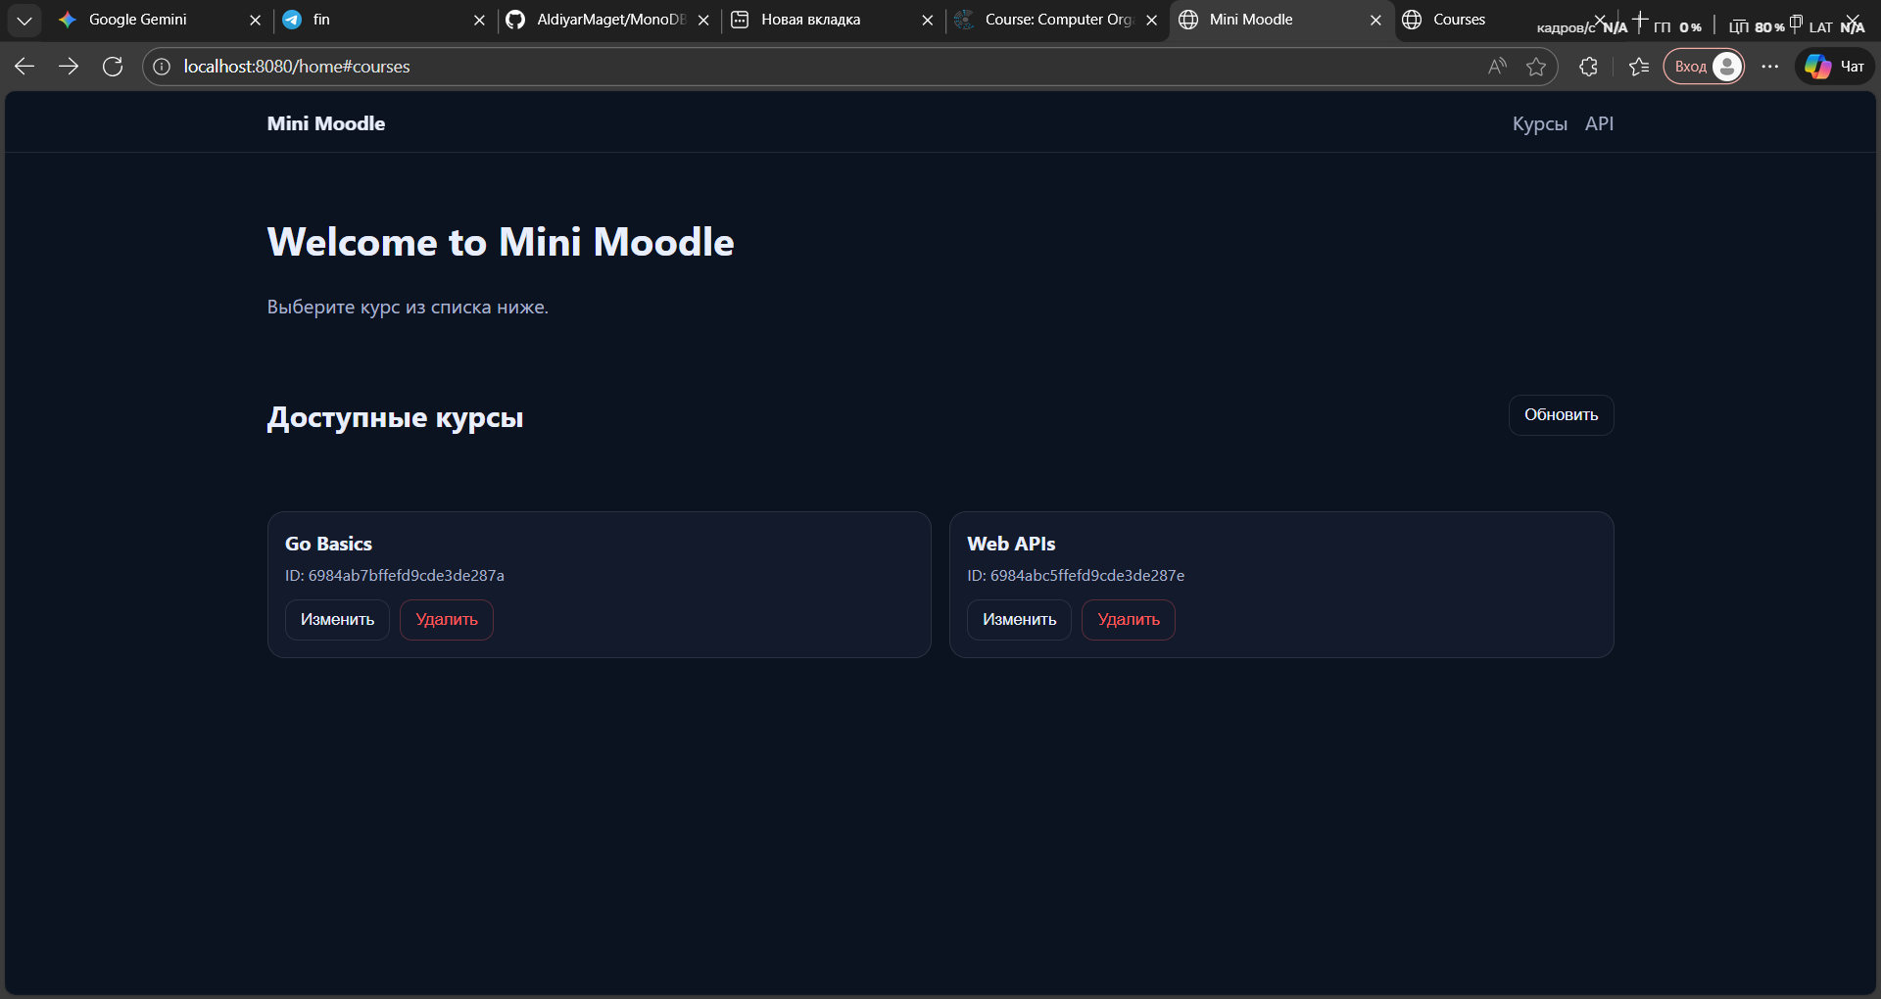

3.2 Backend B & Integration (Implemented by [Developer 2])
- Advanced Course Management: Implemented the GetCourses handler featuring search, category filters, and pagination.
- Course Content Operations: Developed the ability to add, edit, and delete modules using MongoDB $push, $pull, and arrayFilters.
- Progress Tracking System: Built the UpdateProgress logic using Upsert and the $inc operator to track student attempts.
- Data Aggregation: Authored a complex MongoDB Aggregation Pipeline to calculate real-time completion rates and average scores for the profile dashboard.
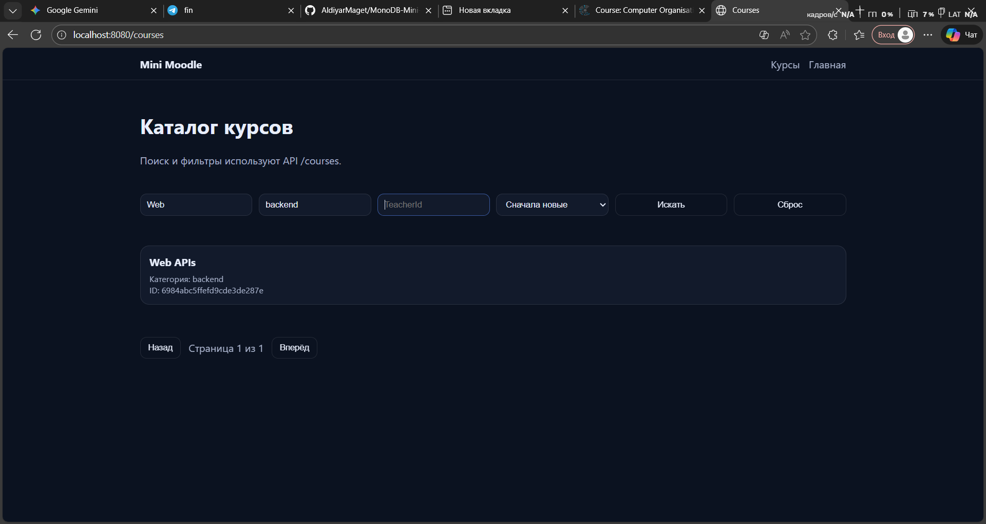

4. Key Technical Features

4.1 Secure Authentication
The system implements a secure gatekeeping mechanism. The AuthMiddleware intercepts requests to sensitive routes (like /profile or /home), ensuring only logged-in users with a valid session_token can proceed.

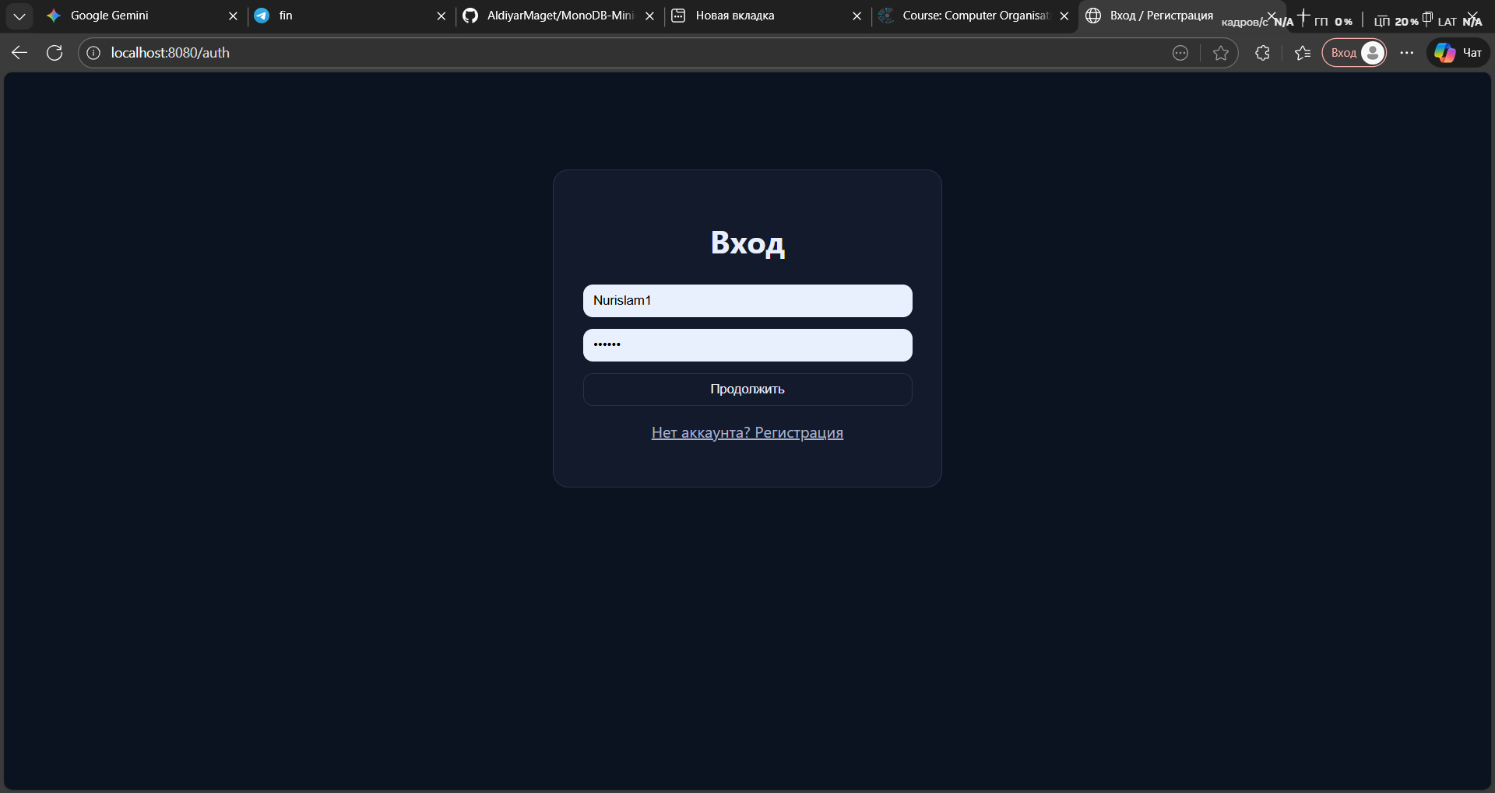

5. Database Schema
Our NoSQL approach allowed for flexible data structures.
Collection | Key Fields | Purpose
Users | username, password (hashed), role | Identity management
Courses | title, modules (nested array), teacherId | Content storage
Progress | userId, courseId, itemId, attempts, score | Learning analytics

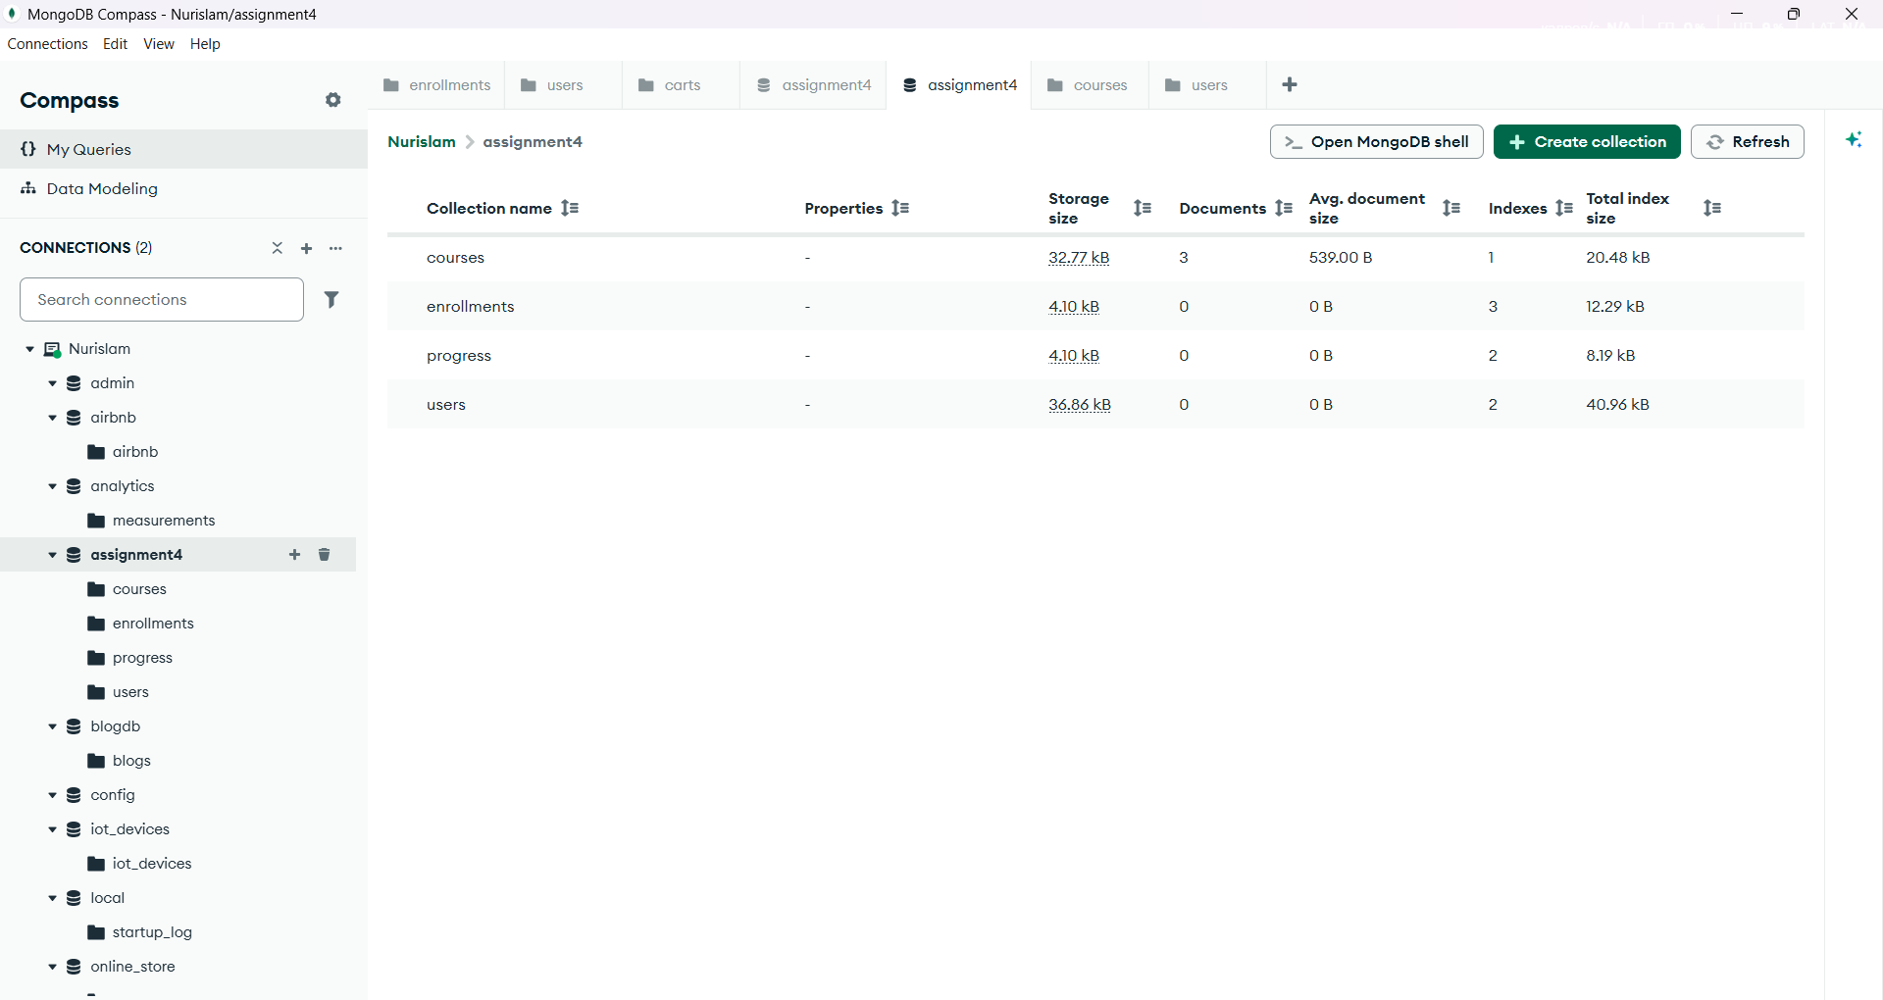6. Challenges & Solutions
- Challenge: Handling both HTML and JSON requests on the same URL.
- Solution: Implemented Content Negotiation in Route.go to detect the Accept header.
- Challenge: Preventing duplicate index errors in MongoDB.
- Solution: Integrated primitive.NewObjectID() during registration to ensure every user has a unique identifier.

7. Conclusion
The Mini Moodle project successfully demonstrates the power of Go and MongoDB in building scalable web applications. By splitting responsibilities into Backend A and Backend B, the team was able to implement complex features like atomic increments and deep-nested document updates, resulting in a robust educational tool.

